Leeds Beckett University

Cloud Service Deployment and Analysis

Module: Cloud Computing Development

Student Name: Ayush Thapa

Student ID: 77297990

Year: 2023

Abstract

This academic report delves into the landscape of cloud computing, focusing on the comprehensive exploration of cloud service providers and models.

Furthermore, the report examines various cloud models, including Infrastructure as Service (IaaS), Platform as a service (PaaS), Software as a Service (SaaS). Through this examination, a critical assignment is made to determine the most fitting cloud model for the deployment of a web service.

The report concludes with the practical application of this analysis, selecting AWS Elastic Beanstalk as the preferred PaaS offering from Amazon Web Service (AWS) for deploying a web application. The chosen cloud provider and model are justified based on factor like performance metrics, cost consideration and overall efficiency. The report concludes with reflection on the implication of utilizing AWS Elastic Beanstalk.

Contents

1. Introduction 5

2. Overview of Cloud Computing Technologies 5

2.1 Definition of Cloud Computing and its characteristics 5

2.2 Cloud computing service models 7

2.3 Cloud computing deployment models 8

2.4 Cloud computing providers 8

2.5 Selection and justification of the cloud provider, the service model and implementation technology 9

3. Development and Deployment of the Cloud Service 9

3.1 Service and Client Development 9

3.1.1 Service specification 9

3.1.2 Service development and implementation 9

3.1.3 Client development and implementation 9

3.1.4 Local service testing 10

3.2 Service Deployment with the Cloud Provider 10

3.3 Service management 10

4. Conclusion 10

5. References 10

References 10

# Introduction

# Overview of Cloud Computing Technologies

## Definition of Cloud Computing and its characteristics

The Cloud, refers to server that are accessed over the internet, and server contains the software and databases. Cloud Computing allows users and companies to be free from responsibility managing physical servers, or even develop the applications on their local machine. To support this, data centers for cloud servers are distributed worldwide (Cloudflare, 2023).

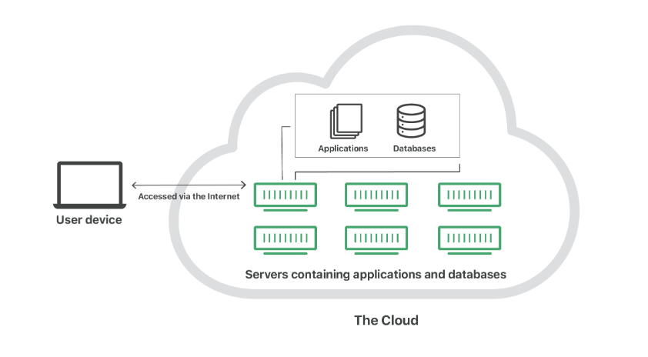

According to the National Institute of Standards and Technology, the cloud enables the global, on-demand network access to a shared pool of configurable computing resources (e.g., networks, servers, storage, applications, and services) that can be rapidly provisioned and released with minimal management effort or service provider interaction. The cloud computing is composed of five essential characteristics, three service models and four deployment models (Mell & Grance, 2011).

Essential Characteristics:

On demand self-service:

User can independently and instantly access and manage computing resources without needing direct interaction with the service provider. This feature provides a quick and automated way for the user to get the computer service they require (Bhatia, 2023).

Broad network access:

User can access cloud services over the network and with wide range of devices like smart phones, laptop and desktop computers. Cloud service is easily accessible from different locations and through different means, providing flexibility and convenience for user to connect to the cloud. The quality of the service is dependent on the latency and bandwidth of the network (Bhatia, 2023).

Resource pooling

The computer resources like processing power, memory, storage and bandwidth, are aggregated into a common pool that can be used by multiple users or application as needed. It allows for more efficient utilization, as the resources are dynamically allocated and reassigned based on demand. It enables a flexible and cost-effective approach to managing computing resources, ensuring that they are used efficiently across multiple tasks or users rather than dedicated to a single purpose (Bhatia, 2023).

Rapid elasticity

Users can rapidly and easily expand or shrink their usage of resources like processing power, storage, or bandwidth. It provides service which can accommodate a sudden increase in demand during busy period and scale down during quitter time which ensures that necessary resources are available when needed and aren’t paying for unused resources (Bhatia, 2023).

Measured Service

The usage of computing resources can be tracked and metered. Cloud provides services to monitor, measure and record how much services user consumes. This allows for the transparent and accountable usage of resources (Bhatia, 2023).

These essential characteristics collectively define the fundamental attributes of cloud computing, enabling a scalable, flexible, and efficient approach to services. The subsequent section of the report explores service models and the deployment models.

In this section you should discuss what Cloud Computing is and discuss main features and characteristics of cloud computing.

## Cloud computing service models

In cloud computing there are divided into three main models i.e. Infrastructure as a Service (IaaS), Platform as a Service (PaaS), Software as a Service (SaaS). These models are divided according to the different level of control, responsibility, management, use-case, security, flexibility and scalability they provide (Kumar, 2023).

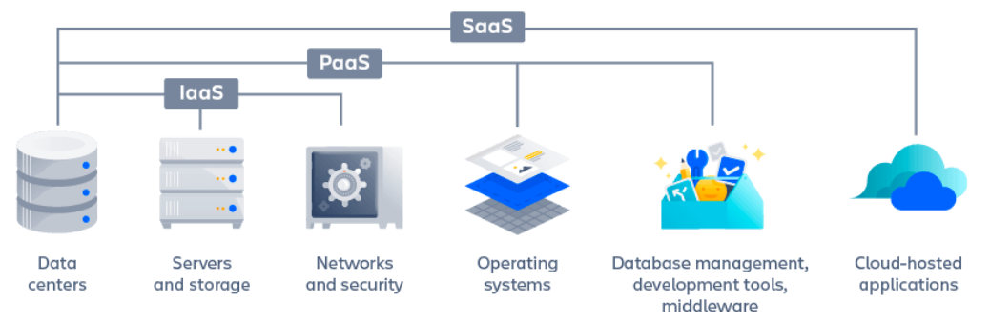

Infrastructure as a Service (IaaS):

In this model, the cloud provider rents the hardware infrastructure such as storage, server and networking resources. User can get this resource on internet using pay-as-per use model. This model eliminates the need for every organization to maintain the IT infrastructure. Here, the cloud service provide (CSP) is responsible for maintaining and managing the infrastructure while user can concentrate on installing, configuring and managing software (GoogleCloud, 2023).

Benefits of IaaS:

1. Economical

The resource is used on demand and the enterprise has to only pay for the compute, storage and networking resources (GoogleCloud, 2023).

1. Reliable

IaaS has no single point of failure. The service will remain available, even if any one component of the hardware resource fails (GoogleCloud, 2023).

1. More innovation

IT team not only have more time to spend on strategic work, IaaS makes it fast and affordable to test new products and ideas. User can easily have a week worth of time, without wasting it by waiting for the necessary computing infrastructure (GoogleCloud, 2023).

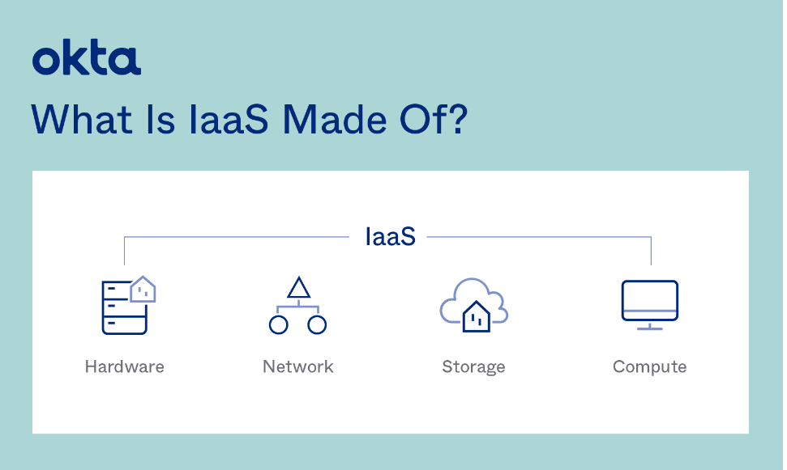

Platform as a Service (PaaS)

Cloud Service Provide offers necessary software and hardware resources. These help the user to develop, run and manage business application without maintain the infrastructure required for such software development process (Kanade, 2022). In this model, the operating infrastructure is not in sight of developers and users, so, underlying servers and resources are controlled by the Cloud Service Provider.

Benefits of PaaS:

1. Cost effective

PaaS eliminates the need to invest in expensive hardware, development tools as all these resources are available as a package which can be launched. Developers can focus on developing the code without worrying about servers, development tools etc (Smact Works, 2019).

1. Maintenance

PaaS offers automated security patches and updates which makes sure application is working on the latest update and there are no security vulnerabilities. It eliminates the need of specialist team to maintain environment on regular basis (Smact Works, 2019).

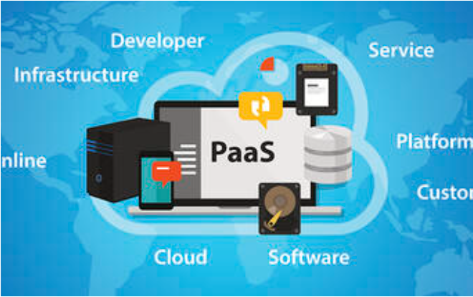

Software as a Service (SaaS):

Pros and Cons

AWS Pros:

**Broad Selection of Services:** AWS presents a broad range of cloud services and solutions which covers computing power, storage, databases, analytics, machine learning, and others, it furnishes a diverse set of tools to address various business requirements (IntelliPaat, 2023).

**Scalability and Adaptability:** AWS helps businesses to adjust their resources based on the its demand, it presents flexible options for compute power, storage capacity, and network resources (IntelliPaat, 2023).

**Emphasis on Security and Compliance:** AWS has high importance on the security of its cloud services, offering broad security features and compliance certifications, the platform provides user with tools and services to help them to protect their applications and data (IntelliPaat, 2023).

AWS Cons:

**Complexity:** Extensive range of services and features can pose difficulty for newcomers. Learning to use the platform may be difficult, and effectively managing AWS resources might take time and training (IntelliPaat, 2023).

**Cost Complexity:** While AWS offers adaptable pricing models, but the pricing structure can be overwhelming, to optimize cost the organizations should be carefully and strategize and monitor their resource consumption. (IntelliPaat, 2023).

**Vendor Dependence:** Similar to other cloud providers, relying too much on AWS can be risky. Switching the application to different cloud can be a lot of work and time (IntelliPaat, 2023).

Microsoft Azure Pros:

**Diverse Service Offerings**: Azure presents a wide range of cloud services, like virtual machines, databases, analytics, and more. It provides a complete set of tools to cater to a variety of business requirements (IntelliPaat, 2023).

**Hybrid Cloud Capabilities**: It supports hybrid cloud setups, enabling organizations to easy integrate their own server with the cloud. This allows enterprises to capitalize on their investment while burrowing the scalability and innovation of cloud computing (IntelliPaat, 2023).

**Integration with Microsoft Ecosystem**: It can work with other Microsoft products and services, like Windows Server, Active Directory, and Office 365. This helps to streamlines management processes and have a smooth collaboration within the Microsoft services (IntelliPaat, 2023).

Microsoft Azure Cons:

**Cost Management:** Managing costs can be tricky even with tools provided to save money, this can be prevented by keeping an eye on how the resources are utilized and following good cost-management practices (IntelliPaat, 2023).

**Documentation and Support:** Even though it offers lots of documentation and support resources, the information might be too complicated or too much, also the support can depend on the service chosen (IntelliPaat, 2023).

**Service Availability:** There might be time where service are temporarily down so, it’s better to have a plan for such disaster to minimize any potential impacts (IntelliPaat, 2023).

GCP Pros:

**Scalability:** Google Cloud delivers scalable infrastructure, allowing users to effortlessly adjust resources based on demand (IntelliPaat, 2023).

**Big Data and Machine Learning:** Google Cloud offers powerful tools and services for big data processing and machine learning, facilitating advanced analytics and insights (Coursera, 2023).

**Security:** Prioritizing security, Google Cloud provides advanced features to safeguard data and applications (Coursera, 2023).

GCP Cons:

**Cost:** Despite flexible pricing options, Google Cloud expenses can accumulate, particularly for resource-intensive workloads or substantial storage requirements (IntelliPaat, 2023).

**Support:** The level of support may vary, and some users might require additional assistance or documentation for intricate scenarios (Coursera, 2023).

**Service Outages**: Similar to any cloud service, Google Cloud is susceptible to occasional outages, potentially impacting business operations (Coursera, 2023).

This section should introduce the most common cloud computing service models including IaaS, PaaS, SaaS, FaaS, etc. and discuss their suitability, proc and contras

## Cloud computing deployment models

This section should introduce and discuss existing cloud computing deployment models including Public, Private and Hybrid Clouds.

## Cloud computing providers

This section should introduce and discuss the most popular cloud computing providers and compare services they offer, prices, SLAs, etc.

## Selection and justification of the cloud provider, the service model and implementation technology

This section should explain your choice of the cloud provider and service model you will be developing in the second part of your report. Describe your implementation technology, language, IDE, cloud frameworks/plugin/add-ons.

# Development and Deployment of the Cloud Service

## Service and Client Development

Using UML diagrams (e.g. Use-Case, block chart, sequence diagram) whenever it is appropriate (e.g. to document service/client specifications, interactions and algorithms) is appreciated and will give you a higher mark.

## Service specification

This section should introduce and describe your service and its functions/operations.

Your service should provide a set of APIs that take one or several input values and produce one or several outputs. As an idea for your service you can consider, for example, a currency exchange service; a stock quote service; a health calculator to estimate BMI, BAI, Waist-to-hip ratio, etc.; a scientific calculator with the extended set of functions; a unit convertor (converting different imperial units to metric and vice versa).

## Service development and implementation

This section should introduce and describe algorithm(s) of your service, give examples of the most important parts of the code and discuss them with technical details.

## Client development and implementation

This section should introduce and describe the client application, give examples of the most important parts of the code and discuss them with technical details.

Your client could be a simple console application. But you will get a higher mark if your client app has a GUI, or a web-form to invoke the service.

## Local service testing

This section should demonstrate outcomes of the local deployment and testing of your service. Use the client app and other suitable tools (e.g. SoapUI) to make sure that your service is fully operational.

## Service Deployment with the Cloud Provider

Here you should provide a step-by step description (a guideline) of the process of the service deployment with the cloud provider of your choice. For example, it could be deployed with PaaS (e.g. AWS Elastic Beanstalk, Azure App), FaaS (AWS Lambda, Azure Functions) or directly on the top of the VM you rented as an IaaS.

## Service management

Here you should show and discuss what options and tools are offered by the cloud provider to monitor the state of your service and manage it (e.g. start, stop, delete, update the version, scale-up/out, login to the underlaying VM, etc.).

# Conclusion

The conclusion should firstly concisely summarise your report (including your service and a cloud provider you used) and then conclude it with any closing remarks you may have regarding Cloud Computing technologies.

# References

# References

Bhatia, V., 2023. *synopsys.* [Online]   
Available at: https://www.synopsys.com/cloud/insights/essential-cloud-computing-characteristics.html#:~:text=The%20National%20Institute%20of%20Standards,rapid%20elasticity%2C%20and%20measured%20service.  
[Accessed 11 December 2023].

Cloudflare, 2023. *Cloudflare.* [Online]   
Available at: https://www.cloudflare.com/learning/cloud/what-is-the-cloud/  
[Accessed 10 December 2023].

GoogleCloud, 2023. *IaaS.* [Online]   
Available at: https://cloud.google.com/learn/what-is-iaas#:~:text=IaaS%2C%20or%20Infrastructure%20as%20a,way%20requires%20time%20and%20capital.  
[Accessed 14 December 2023].

Kanade, V., 2022. *what-is-platform-as-a-service.* [Online]   
Available at: https://www.spiceworks.com/tech/cloud/articles/what-is-platform-as-a-service/  
[Accessed 14 December 2023].

Kumar, A., 2023. *Top 3 Cloud Computing Service Models: SaaS | PaaS | IaaS.* [Online]   
Available at: https://k21academy.com/amazon-web-services/aws-solutions-architect/cloud-service-models/  
[Accessed 11 December 2023].

Mell, p., & Grance, T.(2011) National Institute of Standards and Technology. [Online]

Available at: <https://nvlpubs.nist.gov/nistpubs/legacy/sp/nistspecialpublication800-145.pdf>

[Accessed 11 December 2023].

Aim to have 10+ references, ideally 20+, including scholarly references. This should be implemented using the Harvard referencing style. Make sure that all your references are properly cited in the text of the report. Please refer to the Leeds Beckett University guide below if you are unsure how to do so:

<https://libguides.leedsbeckett.ac.uk/subject_support/harvard_referencing/quote_unquote_online>